Disclaimer:
You don’t really need to read this. I’m making (AKA copypasting) this .doc as a mean of preserving important data about 4chan, its culture and its history in case the original sources go down. Think of this as a time vault for the long future (as long as my hard drive doesn’t die and somebody downloads this)
Most of the text has had its format modified to be more readable and easy to understand. No information has been removed, and small liner notes were added to clarify certain parts of text. Hyperlinks and one-line texts that were there only to suggest clicking a link were removed though, since they don’t fit the purpose of this .doc and would be useless. Links pointing to archived threads were left on purpose in high hopes that said archives will survive for the years to come. Typos were corrected unless they presented names or were made on purpose. No quotes were edited. All parentheses on tittles show the original source of the text.
This particular .doc cover the foundational period of 4chan, based on extracted texts and information’s around the internet. It explains some memes Maybe, if I receive another batch of inspiration like I did when making this, I’ll cover the next period and some of the memes (Cockmongler, George Bush, Waha, tripfags, boards, all the stuff from 2005-2006)

4chan
The early days:
From world2ch:
(Various points of view from players of the time, and some of the very first screw ups and downtimes)
Day Zero - From SA
Unfortunately, moot's original post was edited in '07 and lost forever. It really was the thing I wanted to quote here and went to a whole lot of trouble for nothing. Fuck, after dealing with the no-frills world of 2chan/4chan/4-ch all the time, it's difficult to remember how clunky and stupid [SA's shit homebrew modified] vBulletin is. For anyone that gives a fuck, the first post was 30 September 2003 21:21. If someone saved it, I'd love to have it.
Some interesting shit from the thread that day includes the following:
thatdog wrote: p.s. world2ch sux
Nana-C wrote: I'd figure the best people to handle an english 2channel/futaba board would be actual english webmasters, instead of an underage, clueless webmaster from Japan with almost no english comprehension (and, as a result, a lack of communication to what the english majority wants in a BBS… *ahemworld2chahem*).
Oh, now I remember the reason we were bitter!
Lazy Dog wrote: Ah shit, looks like I'm going to have to mosey on over from world2ch…
Gonna miss that bastard golgolmois, though.
EDIT: Forget it, 4ch is 2chLITE. world2ch UBER ALLES.
moot wrote:4chan.net is up now. Thanks to [NPH]'s hard work we no longer have my four lined half ass page up!
Note: Load times will be slow around 12AM-2AM I believe, this is when the server does tarball backups.
mazfurr wrote: Yeah, what was the point of 4chan anyway when we've got world2ch?
This is Shii's doing, obviously. Btw, check it: I saved the avatar for that mazfurr account. I saved the fuck out of it!$#&*! I saved it on 2 October 2003. Nothing can be deleted on my watch! There is no escaping my archival skills/mental illness!

This is it.
I'm not kidding.
Amazing, no?

Day One - From world2ch.net
This file is a backup of the notorious “Death to Somethingawful” thread on w2ch. For whatever the fuck reason (probably Shii), it has been deleted from archive.org. I'll sum this up and provide some choice quotes out of it later. Pay special attention to Menchi/Shii's stupidity and moot's posts.
Also here:
110 Name: 0037 @A0z7CY5eG2 : 10/01/2003 19:08UTC ID:zZLHX+AA
4chan!?! WTF MAN, you people have foresaken me! Bastard motherfuckers!
111 Name: @VCv4lMCNi2 : 10/01/2003 20:03UTC ID:dcZGC/RI
What a bunch of faggots.
This means we world2chers should show the true power of 2ch, by
trolling the fuck out of them. 2ch style.

WORLD2CH UBER ALLES! MANSE! MANSE!
Hmm… sounds familiar.
The source of the drama was simple: we believed we were ripped off. It was our impression that 4chan had simply taken our code and then apparently had the audacity (somewhere; still working on that) to claim they were the first English language imageboard. There is some evidence to the contrary, but they claimed to have operated completely unaware of us and had translated the code themselves with slightly devastating results (read on).
For whatever reason, Menchi/Shii also had a problem with loli being posted (apparently on DAY ONE, wow). Shii took it on himself to write e-mails to Apis and others alerting them to what he thought were violations of TOS. I still don't fully understand why Shii hated it so much.
A couple of us did stupid shit on /b/. Most were just noisy. I may have been the only creative one as I made this stupid picture (right).
Later Days
Within hours of the first day, 4chan's user base exceeded w2ch's easily a hundred-fold. The war was over instantly. In fact, I more or less give a surrender speech in the dramabomb.txt file >>48. We proceeded to grumble about it, made suggestions on our side, and even taught them a thing or two about their own code… little good it did.

On 9 October 2003, it was pointed out on SA:
Man-Eating Cow wrote: Just to make sure moot knows: The images aren't having thumbnails generated; instead, they're just being shrunk on each index page. Thus every image is being loaded, whether or not people click on all of them. I don't know whether this is the intended operation, but I figure that bandwidth is a lot more expensive than a little bit more disk space and a modest increase in processing power.
Somewhere in the translation, they screwed this up. This is the devastation I've been building up to. Basically, if you posted a 1.1 MB picture, it was transferred to every user looking at whatever page it was on even if they didn't click on it. The 4chan admin’s apparently didn't understand what that meant because the problem was not corrected. On 16 October 2003 an announcement was made on 2chan regarding 4chan. The Japanese invaded and this coupled with the coding error effectively killed the site for the first time:
The reason behind the early death was pretty simple (money). This is by an SA user named nem (real name Matt something, I forget) who runs Apis:
…the server was doing 1 Megabyte per second, mathematically speaking we were looking at doing over ~2530 gigabytes per month, I have a 700 GB limitation, I would incur a lovely fee of ~$1370, I'm not taking that out of my 401k plan at all. Unfortunately 4chan spread like wildfire and was due to annihilating not only my bandwidth quota, but the server (with peaks of over 300 concurrent connections per second). I can't do that, sorry. I'm not ponying the $1370 per month either in fines, so it had to go.
Oh, fun note:
uptime
3:29am up 31 days, 14:41, 1 user, load average: 151.67, 228.55, 179.91
Historically speaking, that is the highest load average I have ever seen in my life.

(17 October 2003 13:19) Fucking lol and fucking emphasis mine. This of course would not be the last time 4chan died.
moot responded (17 October 15:28):
The current plan is to get a new, dedicated server. I've already started talks with two people about getting a server online, one whom I know is trusted alot.
PETER PAYNE–MY FRIEND IN JAPAN contacted me, and didn't check it out, he seems… interested though. The only backup I have is one of /c/'s pictures (old), but I may be able to grab one out of the midnight tarball.
It'll take a few weeks, but I'll be damned if I let the dream die in fifteen fucking days. PayPal is the same as my regular mailing address, moot@raspberryheaven. Thanks to any that have the cash to donate, anything helps.
My friend in Japan is the J-list guy. He'd do something stupid immediately. We're dead for almost two days now. Imagine that shit happening now. The Internet would burn to the goddamned ground without it

(18 October 2003 12:50):
moot said:
MY FRIEND IN JAPAN said:
Okay. Honestly, nothing on 2chan.com looks like something we'd be interested in advertising on. So I don't think we'll be able to help you.
MY FRIEND IN JAPAN is worthless :(
This was about the 300th stupid thing that happened to 4chan in the course of little over two weeks…
On 20 October 2003…
moot said:
SERVER ACQUIRED.
4 days of downtime.
13 days later on 29 October, it was back online. Follow the money trail and you should realize there was significant out-of-pocket cost, donations aside (and there was about to be trouble with that too). It had to be plainly obvious by this point though that 4chan was going to be a really big deal and perhaps worth the effort.
moot said:
handyball was reading the wrong log, the entire site has done over 7GB in less than a day :(
EDIT: 12.17GB, what the fuck?
OR NOT…
In the very earliest days, the bulk of traffic came from Japan. They posted very little but sucked up a lot of bandwidth. Oh, and then this happened on 1 November 2003:
moot said:
Peter Payne declines, more details on your local news at 11.
The unthinkable is considered on 2 November 2003:
Man-Eating Cow said:
I am more than willing to go for a subscription-based access system, and I think that is what it will come to. But it might be a good idea to restrict the access to non-.jp domains to see how that affects the usage. I mean, if a subscription system is implemented after all, there will hardly be any .jp users anyway, unless Paypal works in Japan.
Of course we all know in the end how that went down. Tons of traffic and no financing would be the story for the next couple of years.

Early Content
Very early on all content was imported from Japan or copied from SA. The waha! girl (Suzuran) in particular was very briefly popular (through about early 2005?). There was a lot of hentai at first. With all the oppressed masses migrating over from SA, they were allowed to breathe free for the first time and did they ever.
Not even moot knew about tripcodes so no one used them. People from ADTRW would use a name. Japanese continued to use Anonymous. Those from between the words either went tripped or not at all (hell, we saw Nameless enough to know that's how it went). In fact, there was quite a bit of confusion by the proliferation of the soon-to-be much-loved Anonymous and it confused Westerners. Again, it's just my opinion, but I think the SA crew was fed up with the nonsense over there and responded with an outburst of anonymity and assholery. According to my research and recollection, loli was posted on the first day. That shit would get you banned instantly on SA and yet on 4chan it flourished. The Japanese posters that the others seem to show so much interest on them didn't really seem to be that influential or numerous to me. I do recall a couple instances of the usual Korea hate that shows up anywhere a Japanese person is allowed to speak. Later (the 16 October fiasco), the site was pretty much inaccessible.

In these extremely early times, the board was not heavily populated. For instance, there was a time when /b/ moved so slow that we used to make threads to essentially host pictures we were talking about in IRC (does anyone use that shit anymore?). It was probably quite confusing for those viewing it without the common frame of reference and you'd even get other jerks adding in other pictures like they were trying to play along. Sometimes the thread would be there the next night. That's how slow it was, no joke.
Image left: I didn't make this screen cap but I did save it on 15 Nov 2003. Do some math and note the post count vs. uptime. It was that slow!
I did mention that the Planck epoch was kind of boring. (More) Images forthcoming!

The Nickname/Mascot/Whatever
There is one point that I'd like to bring up that is entirely forgotten (or is it?). The early users were all otaku fucktards and tended to have an unhealthy grasp of Japanese (the modern /b/-tard has an unhealthy grasp on something else). The language uses counters: ippai, nippai, etc. where -pai is a counter (yeah, you'd actually say nihai, but I'm trying to explain this to idiots so give me a break). -pai means something cylindrical like a bottle, glass, or a dildo (or glass dildo). Basically anything that can be shoved… oh, wait. I got sidetracked.
Anyway, the counter ”-ba” refers to flat things, like “sheets of paper” or “leaves.” 2chan is nicknamed “futaba” or two leaves. If I've done my math right here, then 2 + 2 = 4 and therefore it is 4 leaves or yotsuba. This is why the site makes a big deal out of the character Yotsubato who conveniently always has her hair done up in four green pigtails. Well, that was the reason they made a big deal out of her. I imagine anymore, it's because of the many filthy incest doujins going around.
As for why Random is /b/ rather than say /r/, well that's because that's what it was on 2chan. There's little mystery there. Well, kind of. /b/ on 2chan is actually the “2D board” (now split into like five or six on last count).


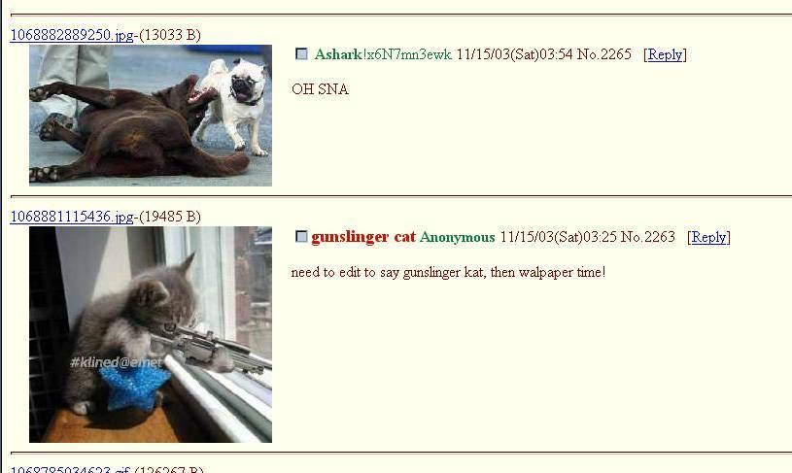

Note: The one above is probably 4chan’s earliest screen cap ever made.
On its precursors:
SA’s ADTRW and #Rasberryheaven (world2ch):
ADTRW
I don’t recall moot being a user of any particular note on ADTRW but then again, it was mostly talk about boring series that only the hardest of hardcore nerds would go out of their way to watch. ADTRW was mostly boring except for the2chan and Azumanga Daioh threads. In addition jerks from ADTRW, jerks from FYAD also contributed heavily to the early era of 4chan (whether they want to admit it or not). ADTRW ran an operation called Raspberry Heaven (which references Azumanga Daioh) which was involved in manga translation (and fansubbing? I forget). They had their own forums apart from the greater SA and if I recall correctly, there were some people involved in RH that had nothing to do with SA (for one of the many reasons stated above).
ADTRW is notable for being one of the less-lame anime forums out there. The users aren't nearly as pathetic as they tend to be elsewhere and the Japan love not nearly as strong. A lot of the fandom is tongue-in-cheek and it tends to filter out good series quite well where others tend to think anything from Japan is of equal merit. I will thank it for exposing me to Azumanga Daioh which I hate to admit I like. Or at least it was. I don't really know the current situation.
Inherited Content
A lot of content migrated over from SA in the early days. In particular, the phrase ”(USER WAS BANNED FOR THIS POST)” is not something you see on futaba, but was used (extensively) on SA and added into 4chan's code. The phrase kill it with fire! is also from there and was usually in regards to spiders over there, which they all had a fear of some reason. That and the ocean (yeah, it's dumb). Truncating a sentence like: Oh shi also seems to have come from there.
The whole concept of an image macro, if not born there, was at least refined at SA. A lot of macros that are reposted on 4chan to this day are older than the site itself and completely ripped off from the SA forums. The modern memegenerator content is a whole new “refinement”…
During the early days, there was a thread on SA which they made demotivational posters. The concept was obviously taken to extremes at 4chan. This may in fact have been 2004-2005, so never mind.
2chan and 2ch (world2ch):
2chan remains a mystery. What the hell they're up to over there is a confusing mess much as we must seem to them.
If there is anything to say about them, it would be that they seem far more capable of staying on topic. Threads go places. Girls in swimsuits? There will be 100 replies all on-topic. I can only chalk this up to the homogenous nature of Japanese culture which is always seeking in every way to conform as hard as possible, usually well past the breaking point and into the depths of severe mental illness.
At the time, aside from Suzuran they were also obsessed with this pencil girl thing. She was a shared artwork, basically. Anyone could add to her weird little story. It was something about her and her pet seal. I never got a straight story on what the hell this was supposed to be, but here's a sample:
In Japan there is basically one forum for all purposes and it is 2-channel. It's enormous, anonymous, and text-only (aside from the porn ads). There are hundreds of different boards on all kinds of topics. You can spend days getting lost in it…
As far as I remember, it was originally a hastily written message board for a television channel web site in the mid-1990s but quickly grew out of control. The site was then moved and disassociated with the network and became its own entity. It developed a culture all its own and now reigns supreme as the place to be online. It is largely anonymous.
Things that have sprung out of it include a few whistle blower scandals and the movie Densha Otoko.

A very cool chart summary of interforum relationships (Macrochan):
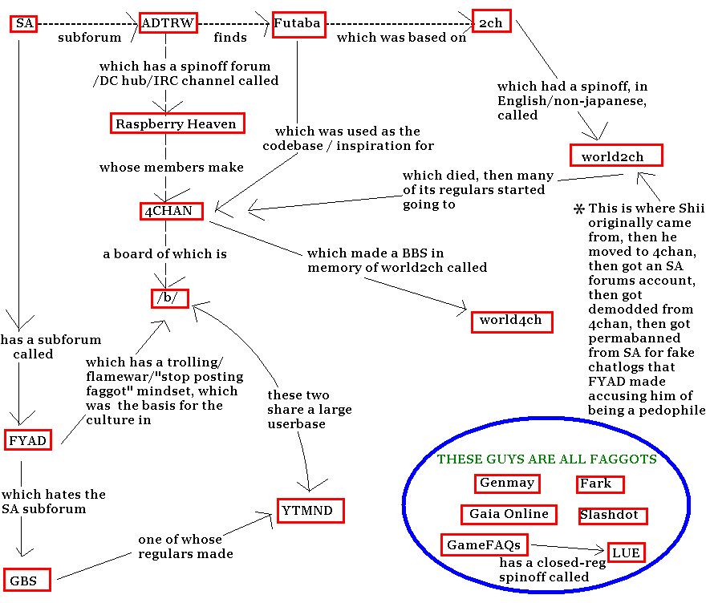
Miscellaneous:
06/2004 news post about the fourth death (AKA not paying the server) of 4chan:
FUN STATS (about 5-6 months of logs):
Successful server requests 631,705,147 Requests
Successful requests in last 7 days 27,337,963 Requests
Successful requests for pages 57,772,752 Requests for pages
Successful requests for pages in last 7 days 2,723,440 Requests for pages
Distinct hosts served 1,076,836 Hosts (note: only for img.4chan)
Distinct hosts served in last 7 days 70,949 Hosts (note: only for img.4chan)
Total data transferred 13.191 TB (note: because the cgi.4chan domain is newer, it slightly threw off this number)
Total data transferred in last 7 days 536.813 GB (note: off due to GNAA flood, usually ~600GB+)

11/2004 news post about bandwidth usage:
4chan pushes roughly 6.3TB of data/month. That is almost double what we we did in the previous incarnation of 4chan, and this number will double again come December.
On an off-day the site gets over 32,000 unique hits from users all over the world (we're talking Finland, Singapore, Italy, and a host of others here people).
Running 4chan for a full year will cost roughly $7,200.
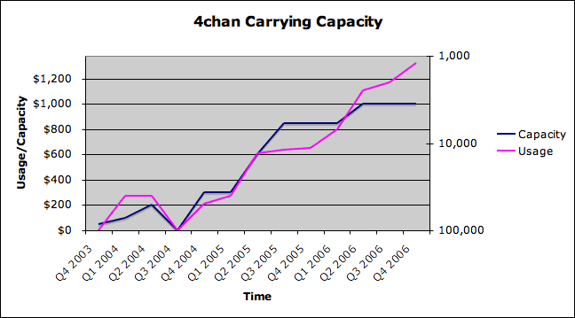
Each dots means a change in the servers: I believe:
Q1 ‘04: Leasing the second server.
Q2 ‘04: Leasing the third one.
Q3 ’04: 4chan goes down for the fourth (And longest) time.
Q4 ’04: Comes back thanks to “The Team”.
Q3 ’04: DONATE OR DIE 2005. The last time donations were asked for. Successful, moot manages to buy three DELL servers.
Q2 ’06: A leased server?

Trivia:
25 Name: Menchi @lWV9WxNHV. : 10/02/2003 14:02UTC ID:??? By Other Language (Permelink)
>>22 /"Yaoi and dickgirlz" is there because it's funny./
It's not funny when they're actually posting child porn to their imgboards! I have half a mind to call their ISP on them.
>>23 /If we can draw attention to ourselves, world2ch might live./
Er... you noticed... :)
(world2ch, actually Shii in disguise, second day of the foundation of 4chan)
/b/ didn’t last one day.
38 Name: moot: 10/02/2003 21:32UTC ID:??? By Other Language (Permelink)
>>21 Stop using "their" please, thanks. That board was merely the first thing I stuck up. I do not care if it becomes a shitfest, as it will be taken down when I find people to moderate (read: NAZI BAN) the serious anime boards. Moderation is the only way we can keep this evil evil pedo hentai out, because we all know ADTRW is a bunch of 40 year old pedophiles who have nothing better to do than look at pictures of women and children with penises! (world2ch again)
It’s also stated in the early news posts that /b/ was meant to be a retard bin.
Early Deaths:
First death – 2003, October 16 - 29– Crashed for two days due to a massive flood of Japanese users, once 2chan noticed 4chan. Apis later decided to kick him out of hosting, he spent the next two days looking for other options (Including asking Peter Payne, owner of the j-List)
After talking about it on SA (And RH?) Moot moved hosting from Apis to United Colo (Apex?). He then fixed many problems on the code (Mainly a bug that caused a huge load of data to be transferred - That was the reason moot was kicked from Apis.

Second death–2003, November 20 - 21 – Moot get’s kicked off his hosting, reformats the servers to RH9. New hosting is GoDaddy.
Third death – 2004, February 11 - 16 – SA user nubdestroyer emails GoDaddy, then 4chan.net’s owner and succeeds in asking to take it down. GoDaddy suspends 4chan.net for three days without moot realizing. He then registers 4chan.org.
Fourth death – 2004, June 20 - August 07 – Among other things, several donations, fundraisers, begging the users to contribute, lack of quality staff and coders, moot finally grows pissed. Pissed and unable to pay for hosting.
Fortunately, some users and members of the staff contact him to begin again, this time with everything more or less planned. Thus, the team is born.

Suspected deaths:
2004 January 03: Either the CP flood or inability to pay.
2005 July 01: Not a real death. But some bizarre sabotage attempt to close 4chan by telling that moot left the project and 4chan would cease operations soon. Many boards were closed by a mod but ultimately the site didn’t die. Moot posted a very angry newspost the next day. I feel sorry for Majnen

http://forums.somethingawful.com//showthread.php?threadid=724028 – Dead link
world2ch’s webmaster Golgolmois. A Japanese that got his site taken over by Americans, didn’t know how to speak English and looked like he was insane (Or just Japanese).
Oct 01, 2003 12:43
Oct 01, 2003 21:38
Oct 02, 2003 05:25
Originally said September. Since moot started 4chan on October, there was an obvious mistake.

